**Week 2 : Regression with multiple input variables**

2.1 Multiple linear regression

2.1.1 - Multiple features - Duration: 9 minutes9 min

2.1.2 - Vectorization part 1 - Duration: 6 minutes6 min

Vectorization part 2 - Duration: 6 minutes6 min

Optional lab: Python, NumPy and vectorization - Duration: 1 hour1h

Gradient descent for multiple linear regression - Duration: 7 minutes7 min

Optional Lab: Multiple linear regression - Duration: 1 hour1h

Practice quiz: Multiple linear regression

2.2 - Gradient descent in practice

2.2.1 - Feature scaling part 1 - Duration: 6 minutes6 min

2.2.2 - Feature scaling part 2 - Duration: 7 minutes7 min

2.2.3 - Checking gradient descent for convergence - Duration: 5 minutes5 min

2.2.4 - Choosing the learning rate - Duration: 6 minutes6 min

2.2.5 - Optional Lab: Feature scaling and learning rate - Duration: 1 hour1h

2.2.6 - Feature engineering - Duration: 3 minutes3 min

2.2.7 - Polynomial regression - Duration: 5 minutes5 min

Optional lab: Feature engineering and Polynomial regression - Duration: 1 hour1h

Optional lab: Linear regression with scikit-learn - Duration: 1 hour1h

Practice quiz: Gradient descent in practice

Week 2 practice lab: Linear regression

----------------------------------------------------------------------------------------------------------------

Multiple features : Terminologies

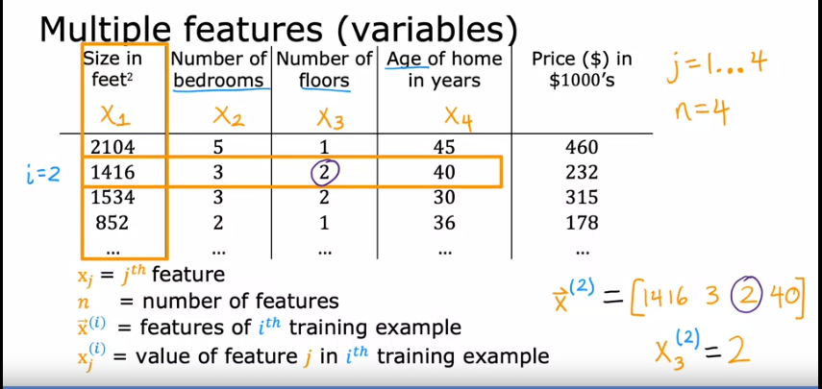

Multiple features : 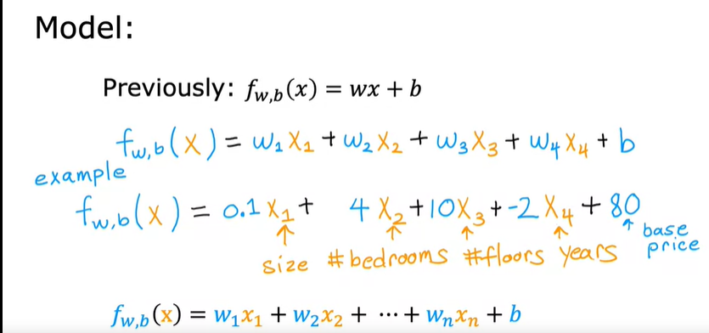

Multiple features : Multiple linear regression

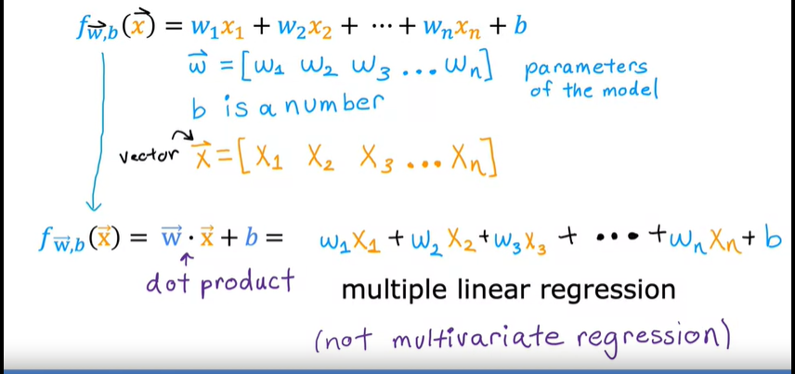

Vectorization part 1 :

To take advantage of modern numerical linear algebra libraries

GPU hardware --> Graphics Processing Unit --> helps to execute vectorised code quickly.--> often used to accelerate machine learning jobs.

Benefits of vectorization : 1) shorter code 2)  results in your code running much faster

The ability of the NumPy dot function to use parallel hardware makes it much more efficient than the for loop or the sequential calculation.

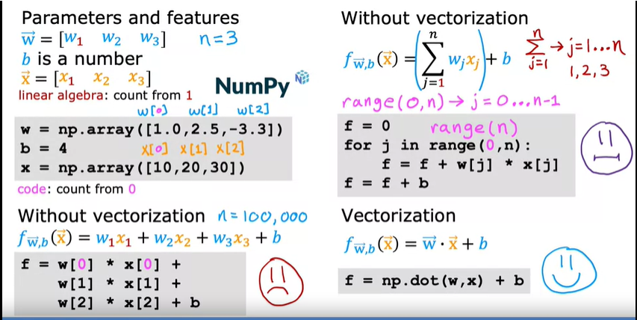

Vectorization part 2 : Behind the Scenes

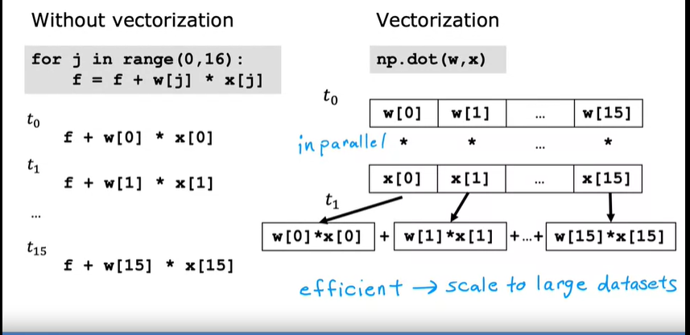

Vectorization part 2 : With Gradient Descent

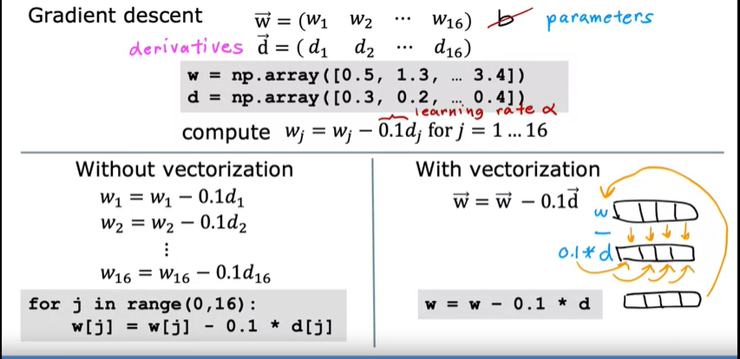

Optional lab: Python, NumPy and vectorization :

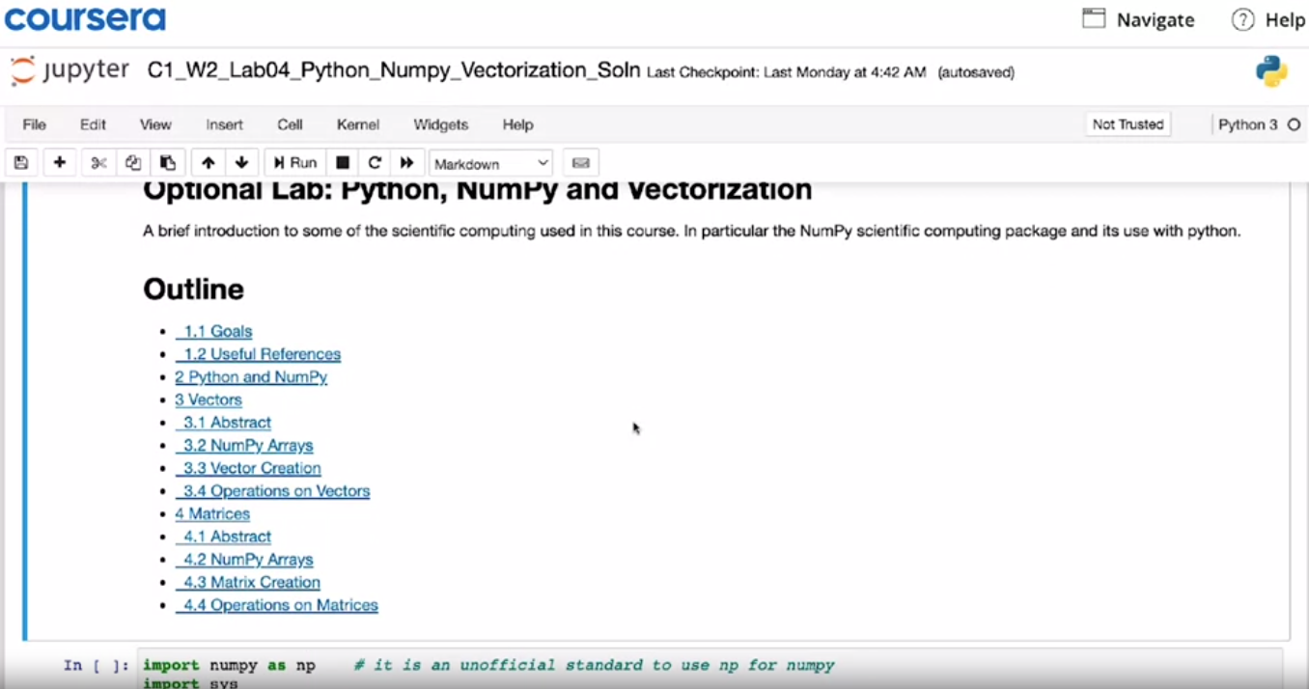

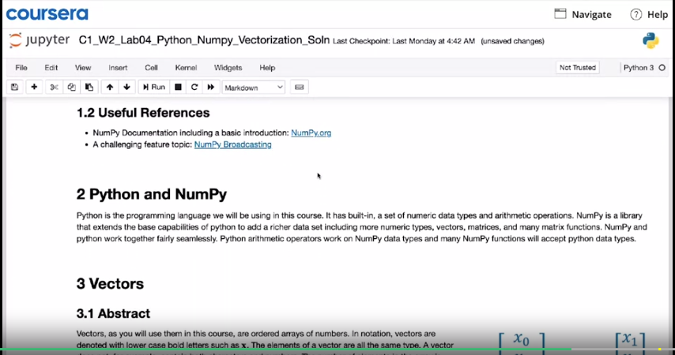

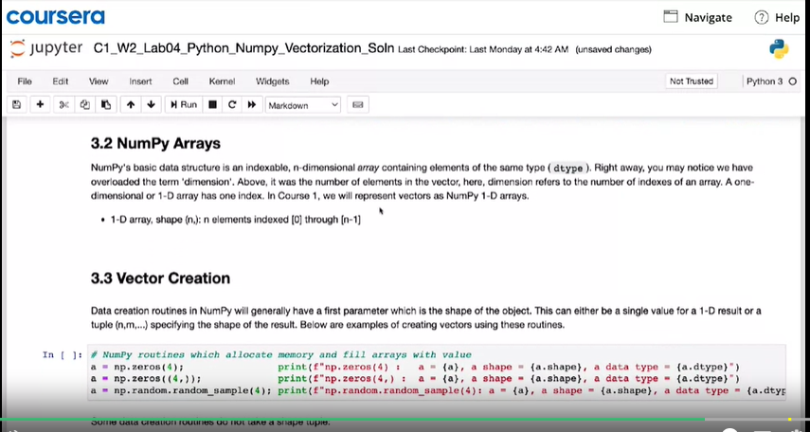

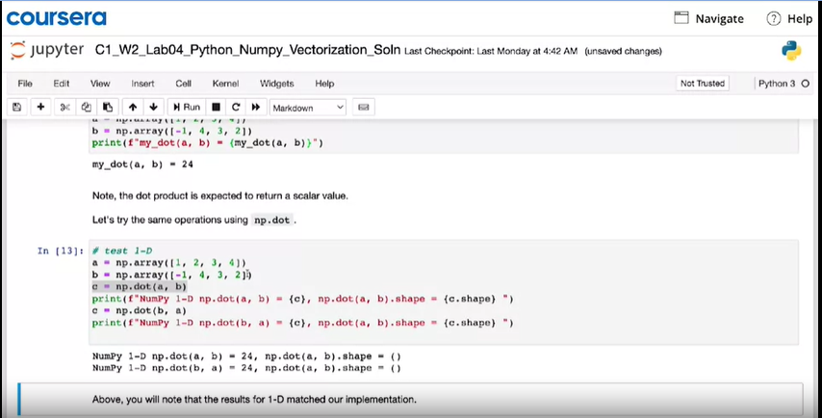

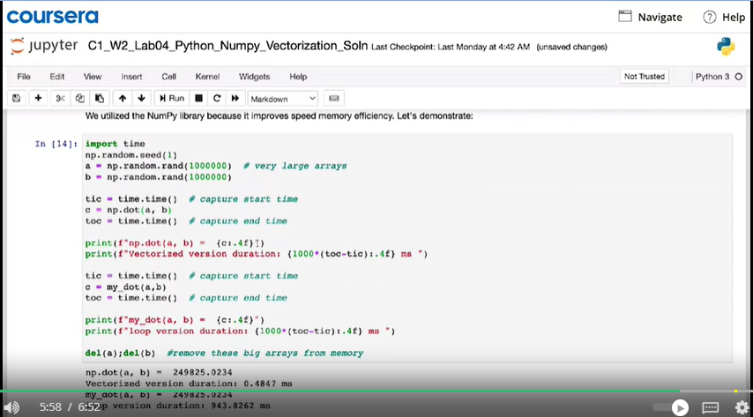

Gradient descent for multiple linear regression :

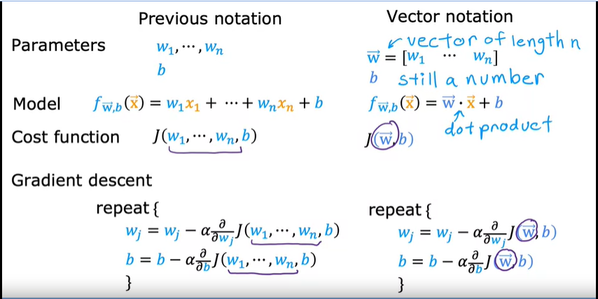

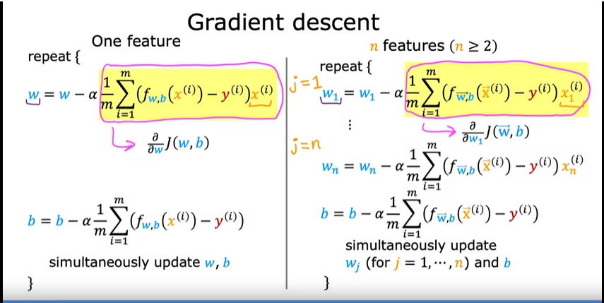

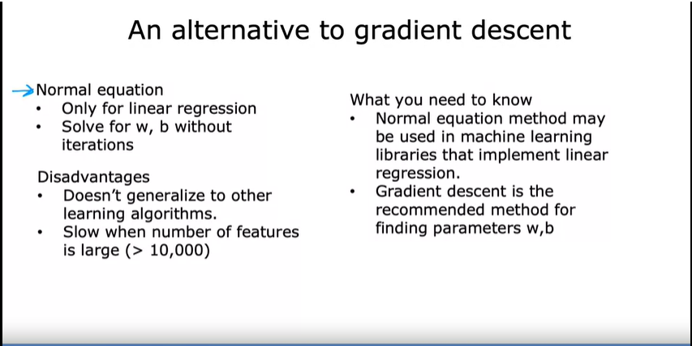

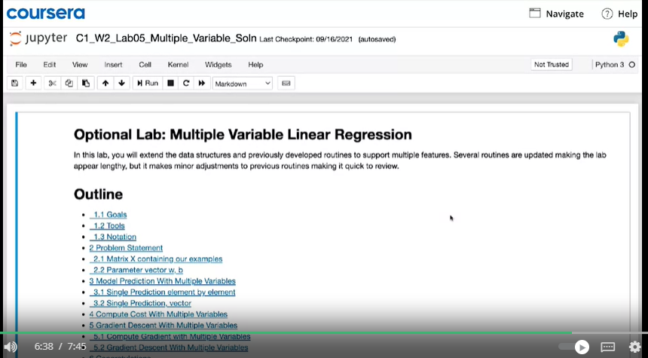

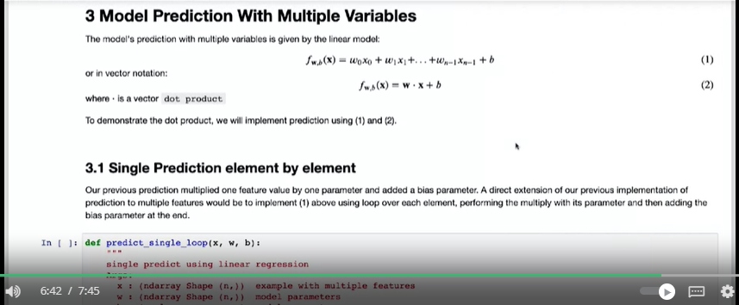

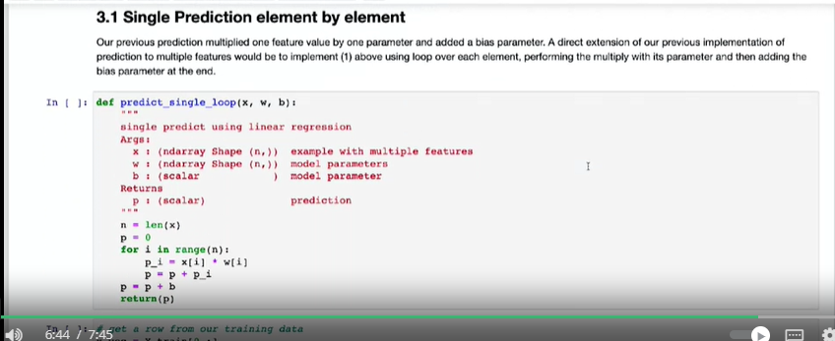

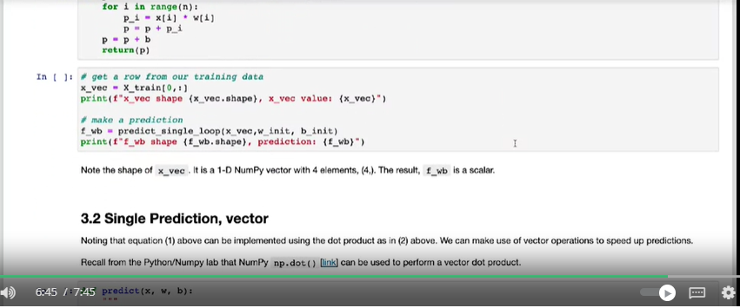

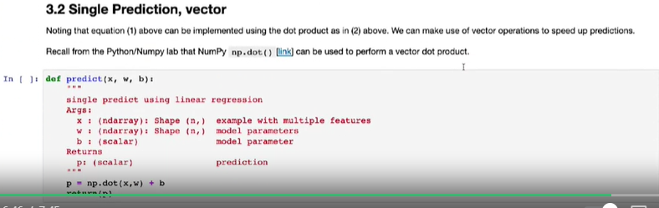

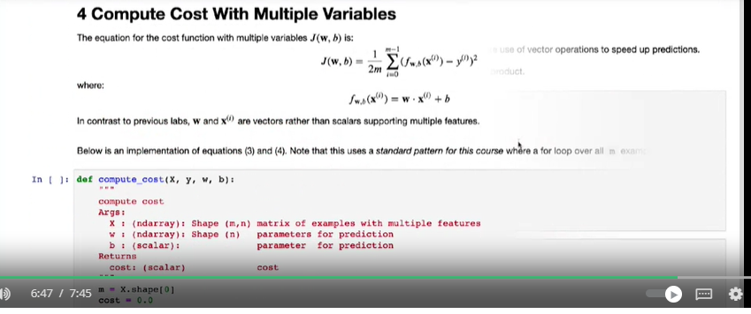

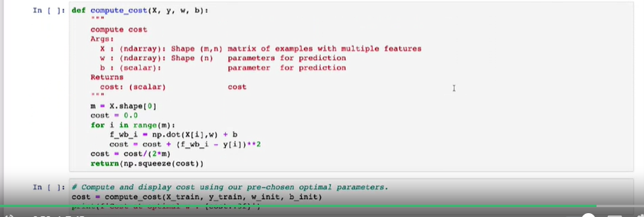

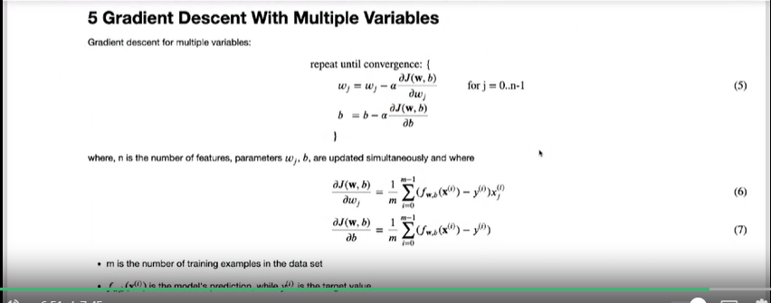

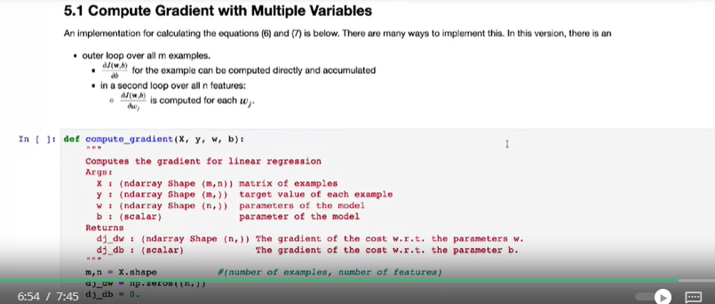

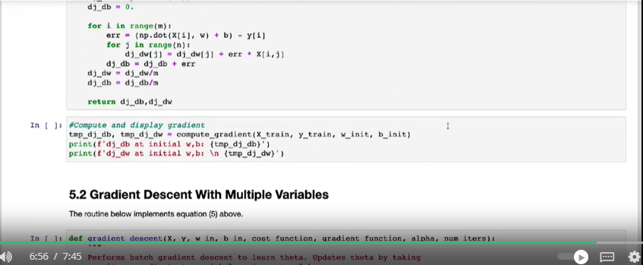

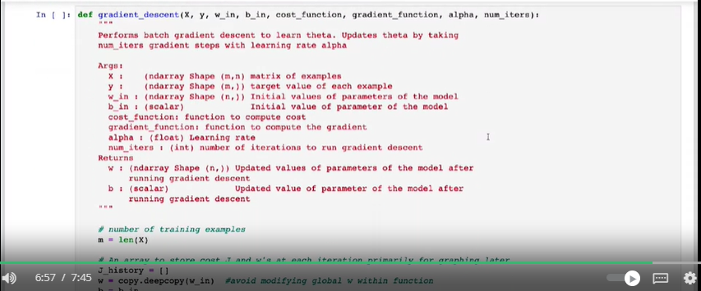

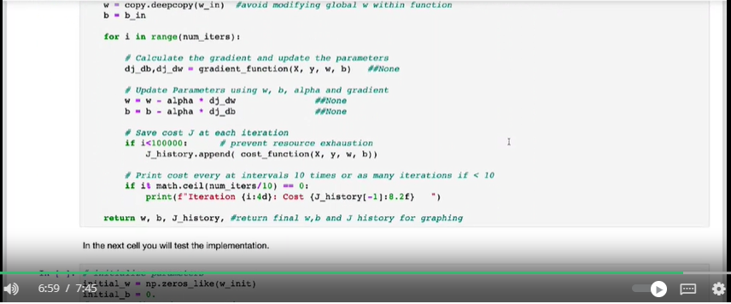

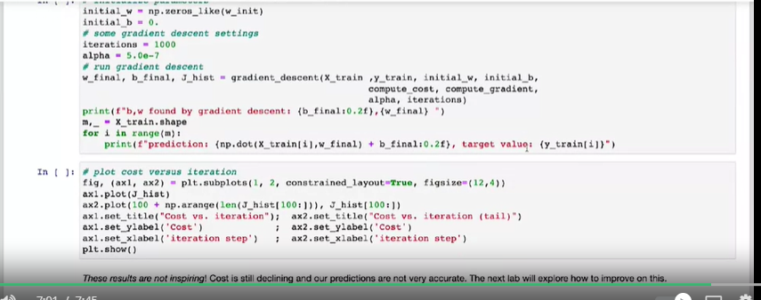

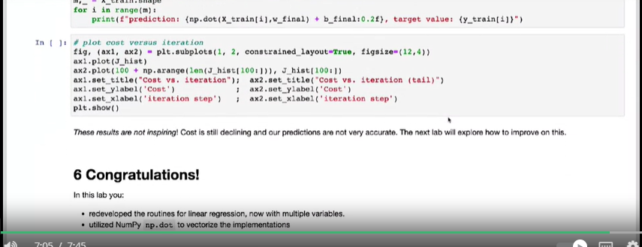

Gradient descent in practice : 2.2.1 - Feature scaling part 1 :

- Enables Gradient Descent to run much faster.

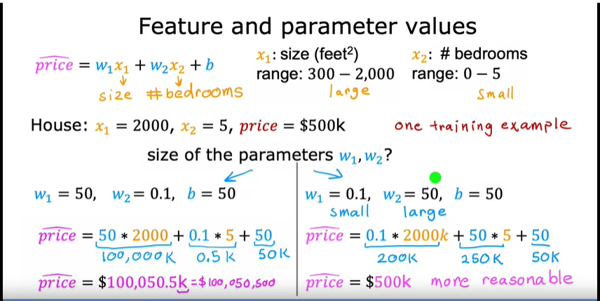

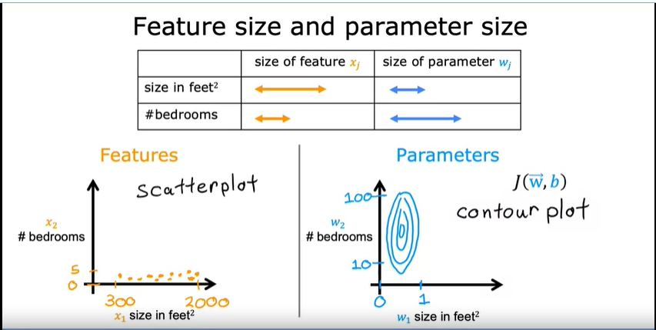

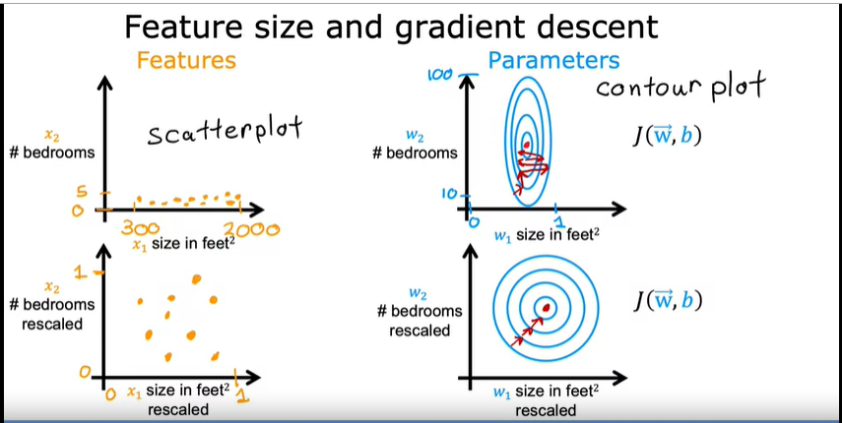

when you have different features that take on very different ranges of values, it can cause gradient descent to run slowly but re scaling the different features so they all take on comparable range of values. because speed, upgrade and dissent significantly.

Gradient descent in practice : 2.2.2 - Feature scaling part 2 : Implementation

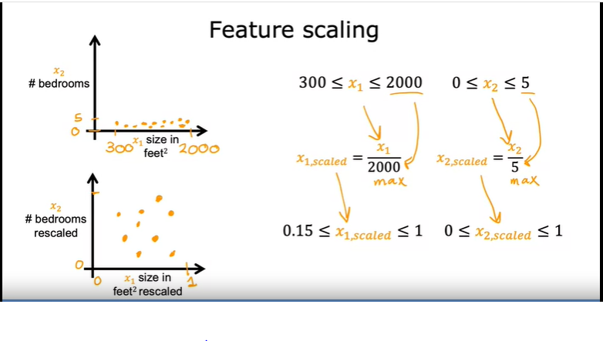

Mean Normalization

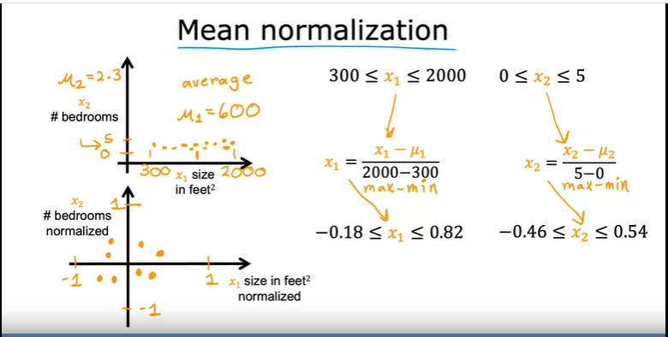

Z-score normalization :

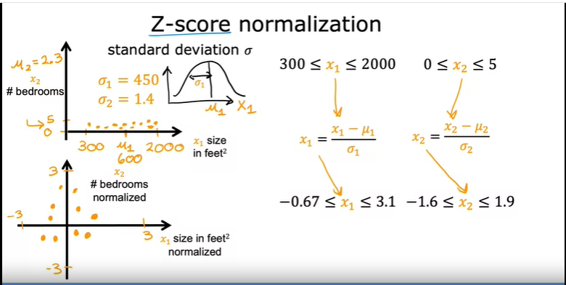

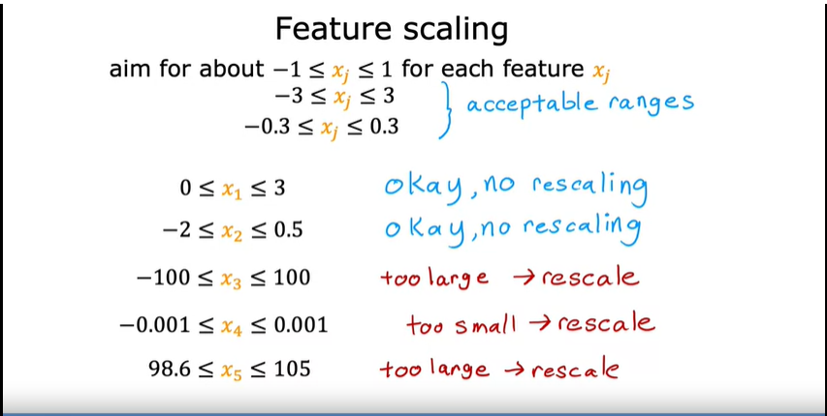

2.2 - Gradient descent in practice : - 2.2.3 - Checking gradient descent for convergence

If gradient descent is working properly, then the cost J should decrease after every single iteration. If J ever increases after one iteration, that means either Alpha is chosen poorly, and it usually means Alpha is too large, or there could be a bug in the code.

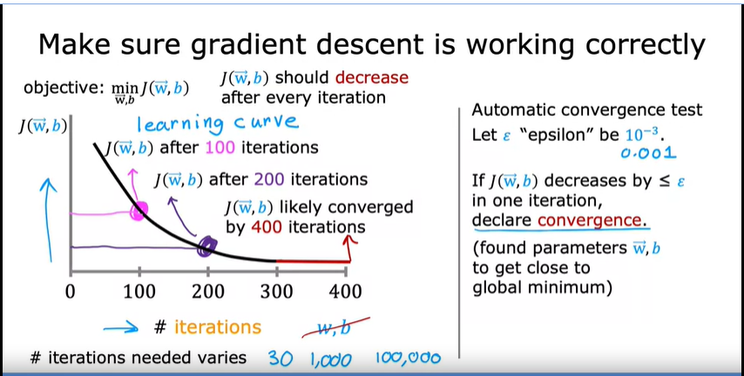

2.2 - Gradient descent in practice : 2.2.4 - Choosing the learning rate :

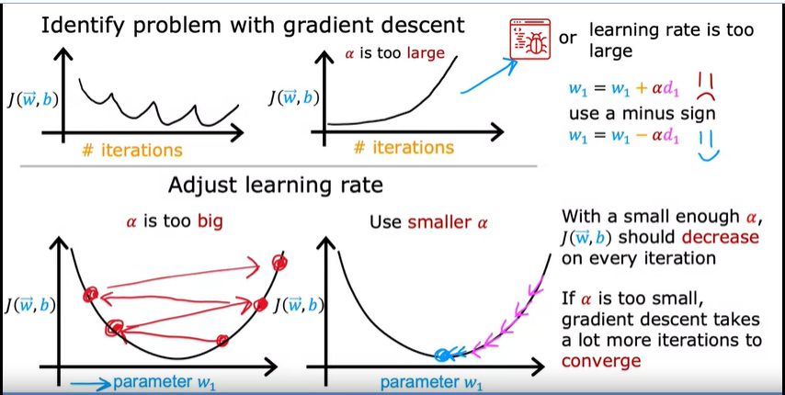

One debugging tip for a correct implementation of gradient descent is that with a small enough learning rate, the cost function should decrease on every single iteration.

So if gradient descent isn't working, one thing I often do and I hope you find this tip useful too, one thing I'll often do is just set Alpha to be a very small number and see if that causes the cost to decrease on every iteration.

If even with Alpha set to a very small number, J doesn't decrease on every single iteration, but instead sometimes increases, then that usually means there's a bug somewhere in the code.

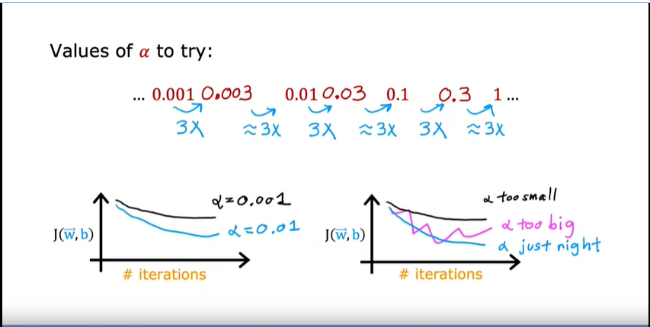

2.2 - Gradient descent in practice : 2.2.5 - Optional Lab: Feature scaling and learning rate

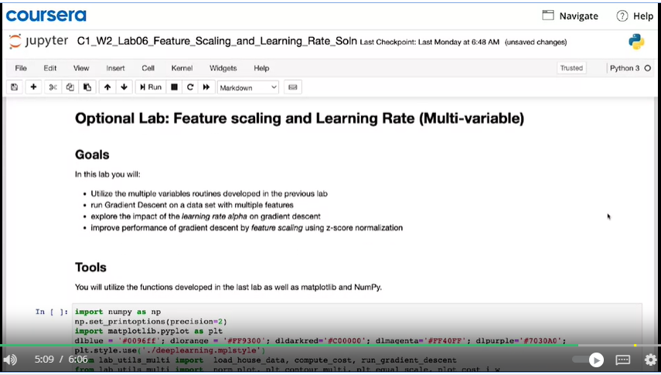

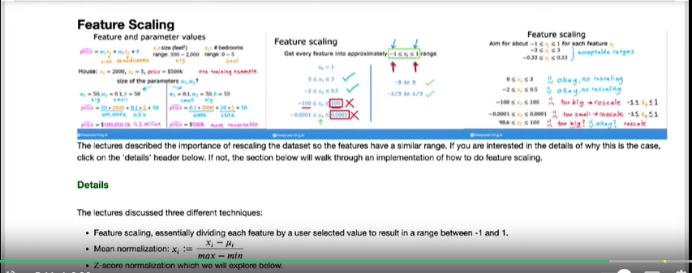

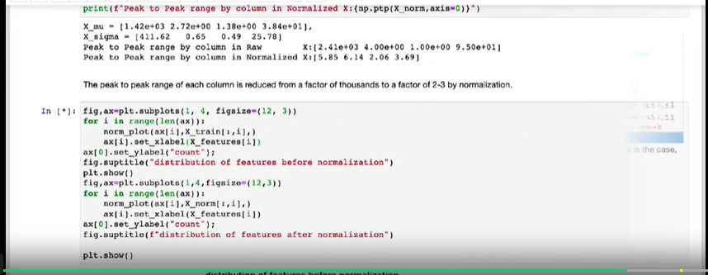

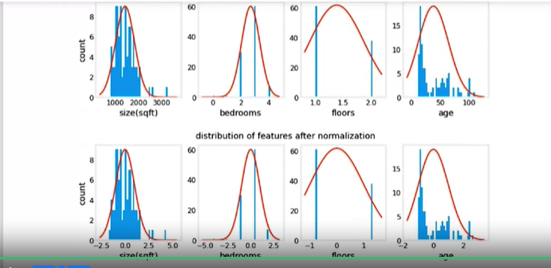

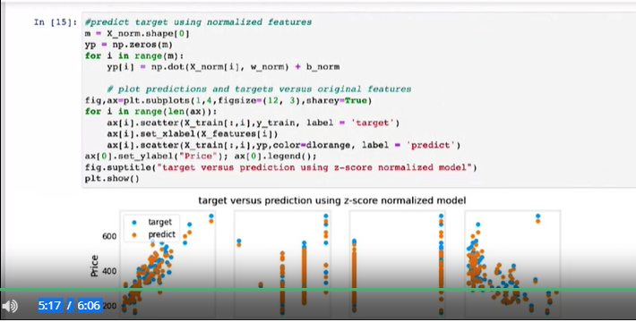

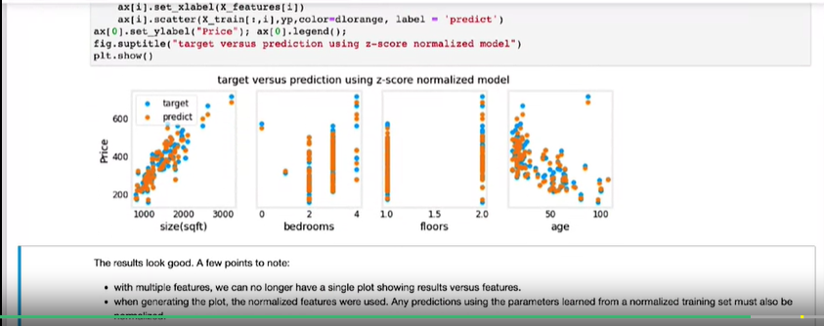

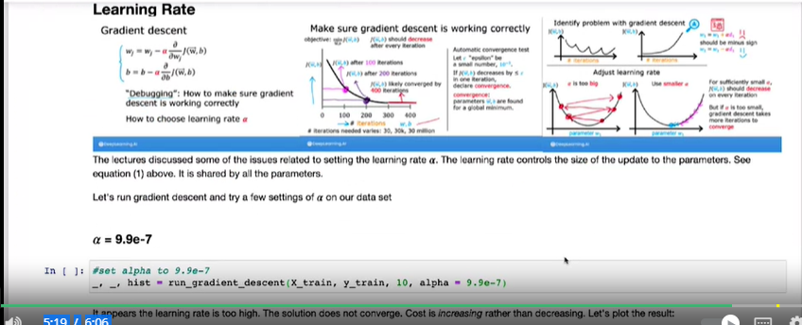

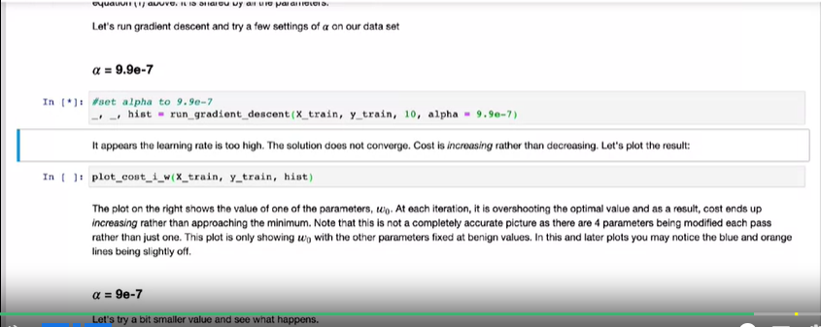

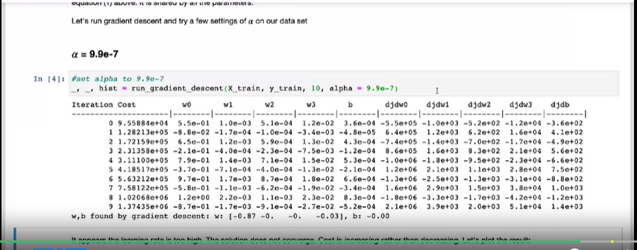

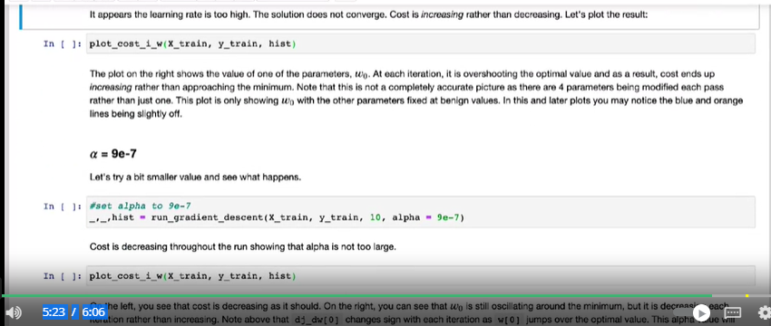

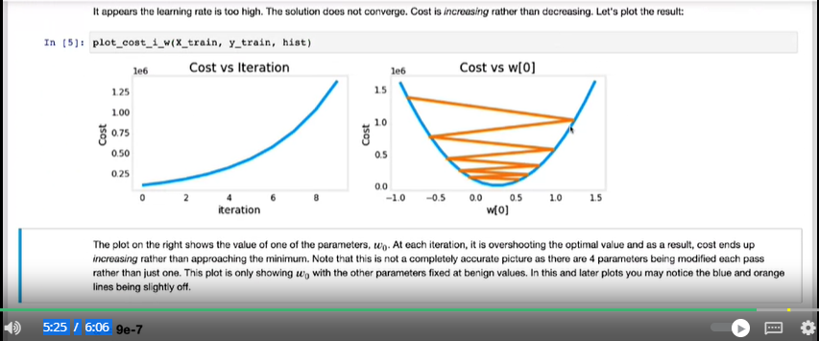

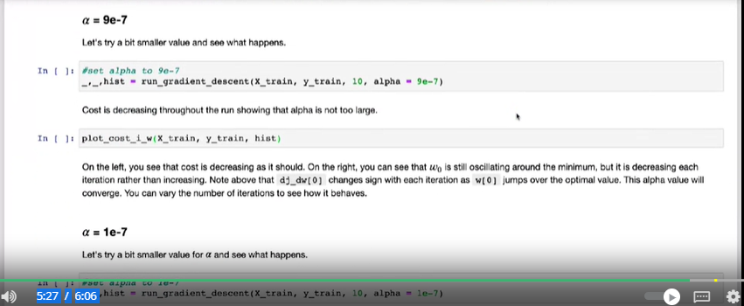

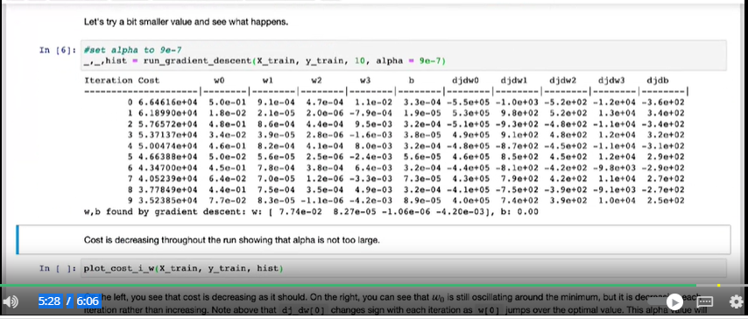

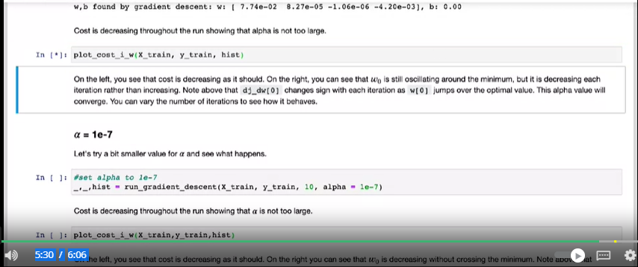

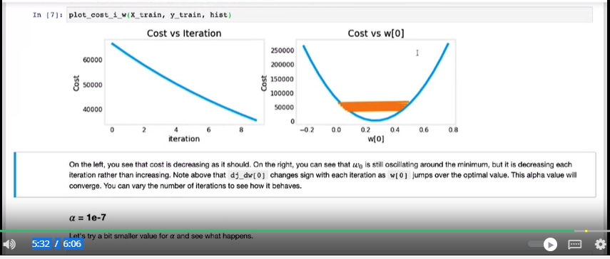

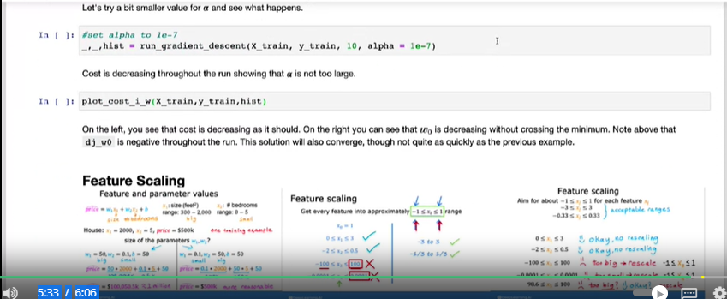

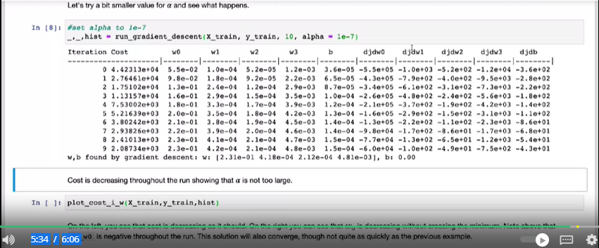

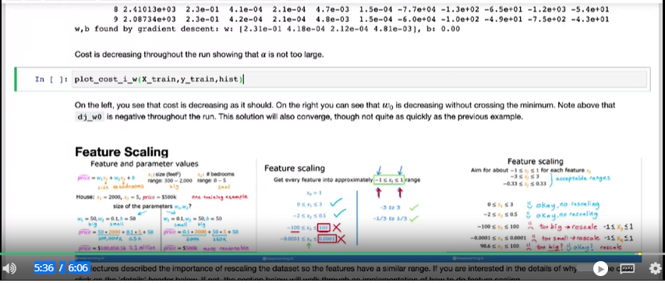

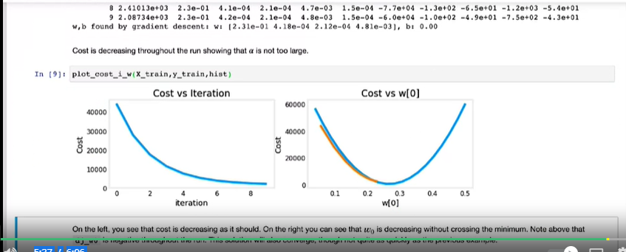

2.2 - Gradient descent in practice : 2.2.6 - Feature engineering :

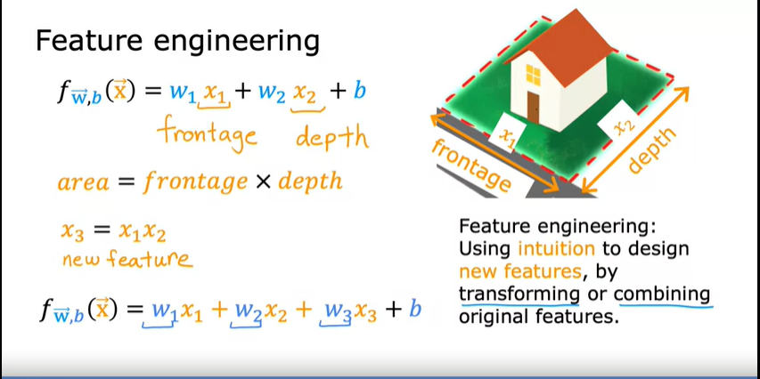

2.2 - Gradient descent in practice : 2.2.7 - Polynomial regression :

